Module 1: introduction
Learn to talk to almost any AI model (like ChatGPT, Claude, Gemini, Llama, DeepSeek...) using code, and do it in a smart, clean way that doesn't break when you switch models.

Why should we learn this?
A few real situations I've seen (and you probably will too):
- Company says: "Use Claude now, it's cheaper/better/safer"
- OpenAI raises prices → you want to switch to Groq + Llama fast
- You want function calling / tools but some models do it differently
- You built something nice with GPT-4o → now you want to test it with Gemini 1.5 or DeepSeek for free/cheap
- You want memory + tools + external APIs (like searching Google, sending emails, checking database) and it should work with any model
If you write code locked to OpenAI only → you suffer every time the price or rules change.
So we learn to write code once → then switch models with basically one line.

What we'll actually build step by step
Think of it like levels in a game:
- Just send message → get reply (any model)
- Make the AI give perfect JSON every time (no random text mess)
- Teach it to use tools (calculator, search, your own functions)
- Add memory so it remembers previous messages
- Add long-term memory (save important facts forever)
- Handle rate limits, retries, cheap fallbacks automatically
- Put everything together → build something useful like research helper, email drafter, or personal assistant

Quick look how the flow usually looks (real apps)

Here's a simple picture version many people use:
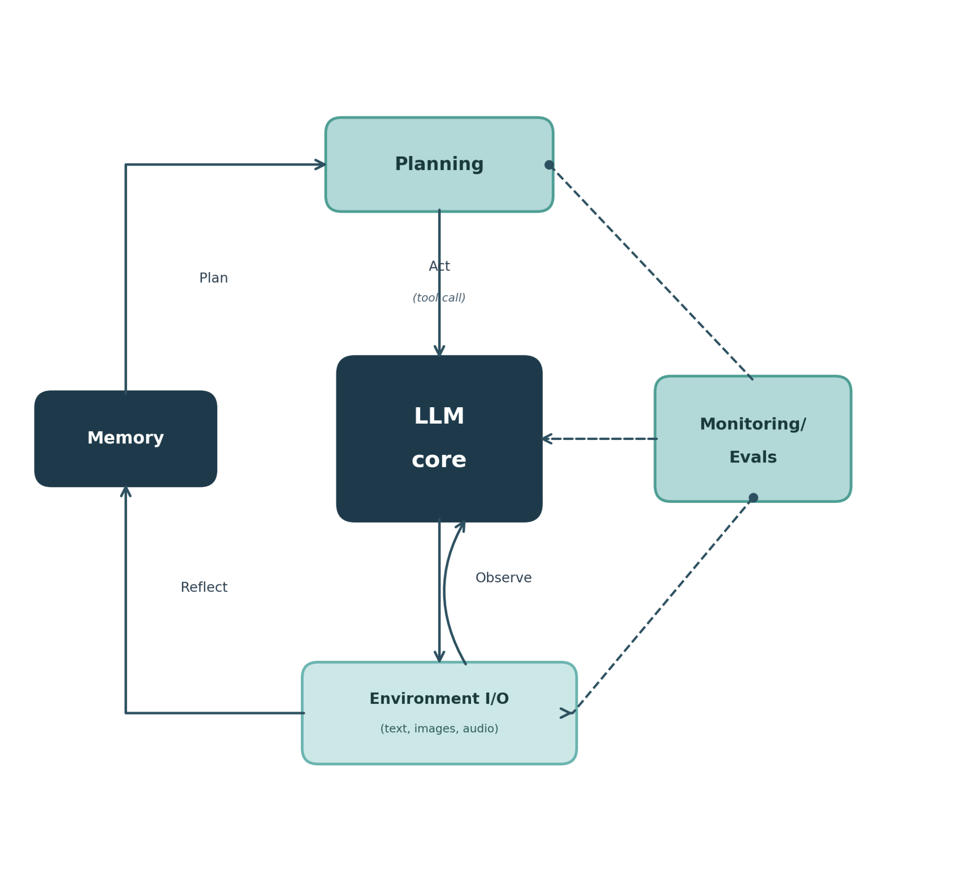
(LLM in middle + memory + tools + planning loop, very common pattern)

And another one — long-term memory part:
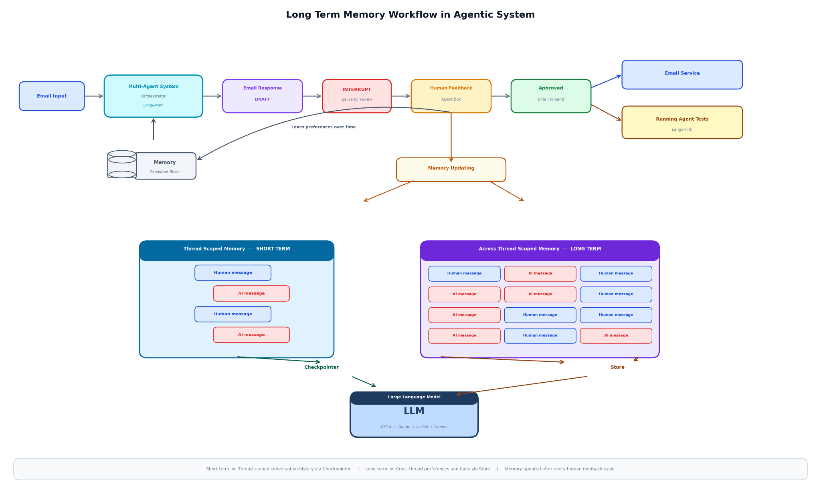

Big benefit people want in 2025-2026
- One codebase → many models (no rewrite)
- Before = pain (different code everywhere)
- After = clean (one nice gate/unified way)
And fun part, some people even imagine teams of different AIs working together

Module 2: Mastering LLMs & APIs – Connect to Any Model, Add Tools & Memory

Goal
- Write code once → talk to GPT-4o / Claude 4 / Gemini 2 / Llama 4 / DeepSeek / Grok etc.
- Send structured requests → get reliable JSON/tool calls
- Add tools (search, calculator, your shop database)
- Add memory (remembers customers)
- Handle rate limits, retries, cheap fallbacks
Build production-ready agents without rewriting code every time prices change or a new model drops.

Why this really matters nowadays:
Your shop gets 20–30 WhatsApp messages/day:
"Screen tod gaya bhaiya, kitna time lagega?"
You reply manually → slow + tired.
The AI replies politely in Hindi/English, checks price/stock, books slot, remembers "Raman prefers Samsung parts", switches to cheaper DeepSeek when busy.

1. Setup (Do Once – 5 Minutes)

Install core libs:

pip install litellm python-dotenv pydantic langchain langchain-community chromadb requests tenacity

Create .env file in your project folder (never commit to git!):
OPENAI_API_KEY=sk-...
ANTHROPIC_API_KEY=sk-ant-...
GEMINI_API_KEY=AIza...
GROQ_API_KEY=gsk_...
TOGETHER_API_KEY=...
# Add more as needed (DeepSeek, Fireworks etc.)

Load them safely:
from dotenv import load_dotenv
load_dotenv()

Get free keys today:
- OpenAI → platform.openai.com
- Anthropic → console.anthropic.com
- Google Gemini → ai.google.dev
- Groq (fast open-source) → console.groq.com
- Together.ai / Fireworks.ai for more open models

2. Core Idea: Unified LLM Caller (Write Once, Switch Forever)

LiteLLM makes 100+ models look like OpenAI format.
# llm.py – your central file
from litellm import completion
import os

def ask_llm(
prompt_or_messages,
model="openai/gpt-4o-mini", # ← change ONLY here!
temperature=0.7,
max_tokens=500,
tools=None, # for function calling later
response_format=None # for structured JSON
):
if isinstance(prompt_or_messages, str):
messages = [{"role": "user", "content": prompt_or_messages}]
else:
messages = prompt_or_messages

try:
response = completion(
model=model,
messages=messages,
temperature=temperature,
max_tokens=max_tokens,
tools=tools,
response_format=response_format,
api_key=os.getenv(f"{model.split('/')[0].upper()}_API_KEY") # auto picks key
)
return response.choices[0].message
except Exception as e:
print(f"Error with {model}: {e}")
return None

Test it:
msg = ask_llm("One fun fact about Bhopal?")
print(msg.content)

Now change model= to:
- "anthropic/claude-3-5-sonnet-20241022" (or newer Claude 4 variants)
- "gemini/gemini-1.5-flash" (or gemini-2.0)
- "groq/llama-3.1-70b-versatile" (super fast)
- "deepseek/deepseek-chat" (cheap reasoning)
Same code — different brain. That's the win.
Here’s a visual of what this unification looks like in practice:
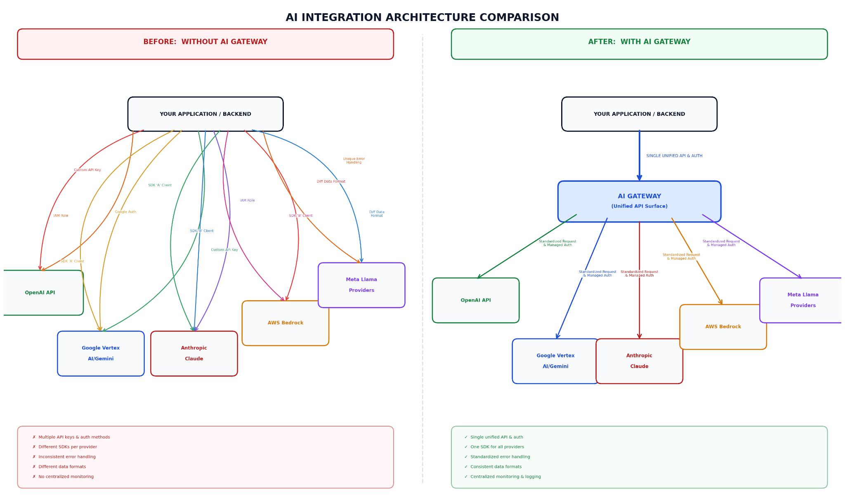

3. Structured Outputs – Guaranteed JSON (No More Parsing Mess)

Use Pydantic + response_format.
from pydantic import BaseModel, Field

class RepairReply(BaseModel):
greeting: str = Field(description="Polite hello in Hindi+English")
model_ask: str = Field(description="Ask for phone model if missing")
price_quote: str | None = None
slot_suggest: str | None = None

response = ask_llm(
"Customer: Screen broken. Reply helpfully.",
model="openai/gpt-4o-mini",
response_format={"type": "json_schema", "json_schema": RepairReply.model_json_schema()}
)

print(response.content) # valid JSON every time

Claude/Gemini support similar via tools or json mode.

4. Tool / Function Calling (AI Uses Calculator, Search, Your APIs)

Define tools like OpenAI format (LiteLLM normalizes for all).
tools = [
{
"type": "function",
"function": {
"name": "get_current_price",
"description": "Get repair price for phone model",
"parameters": {
"type": "object",
"properties": {"model": {"type": "string"}},
"required": ["model"]
}
}
},
{
"type": "function",
"function": {
"name": "book_slot",
"description": "Book repair slot for customer",
"parameters": {
"type": "object",
"properties": {
"customer_name": {"type": "string"},
"time": {"type": "string"}
},
"required": ["customer_name", "time"]
}
}
}
]

# In ask_llm pass tools=tools

Loop example (simple ReAct-style agent):
def run_agent(query, model="groq/llama-3.1-70b-versatile"):
messages = [{"role": "user", "content": query}]
while True:
resp = ask_llm(messages, model=model, tools=tools)
messages.append(resp)

if not hasattr(resp, 'tool_calls') or not resp.tool_calls:
return resp.content # final answer

for tool_call in resp.tool_calls:
func_name = tool_call.function.name
args = json.loads(tool_call.function.arguments)

if func_name == "get_current_price":
# fake db call
result = f"₹{1500 if 'samsung' in args['model'].lower() else 2000}"
elif func_name == "book_slot":
result = f"Slot booked for {args['time']}"
else:
result = "Tool not found"

messages.append({
"role": "tool",
"tool_call_id": tool_call.id,
"name": func_name,
"content": result
})

print(run_agent("Fix my iPhone screen tomorrow morning?"))

This flow (very common agent pattern):
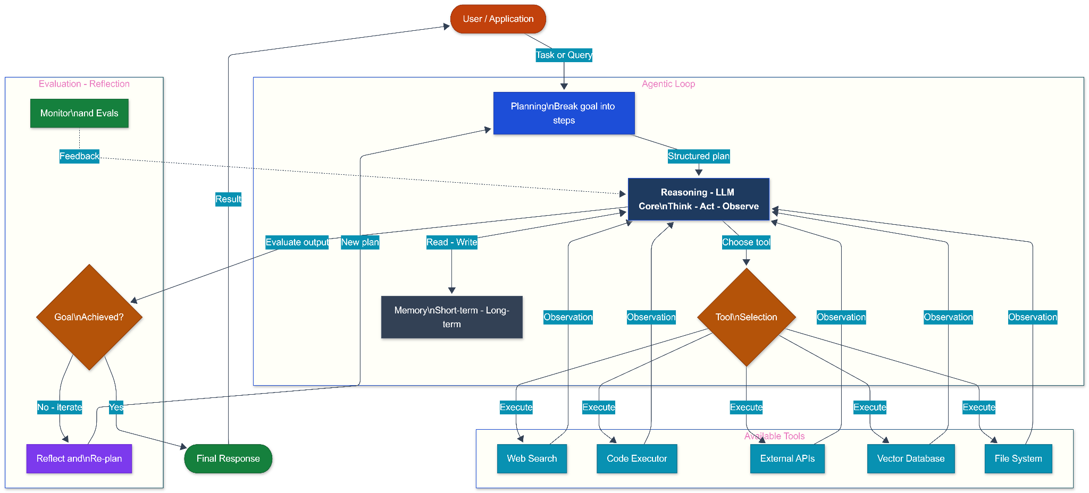

5. Memory Integration
Short-term (conversation history):
Use list of messages — just keep appending.
Long-term (persistent facts, customer prefs) – use Chroma vector store + RAG.
from langchain_community.vectorstores import Chroma
from langchain_openai import OpenAIEmbeddings # or use free HuggingFace embeddings

embeddings = OpenAIEmbeddings()
vectorstore = Chroma("shop_memory", embeddings)

# Save fact
vectorstore.add_texts(["Raman prefers fast delivery and Samsung parts."])

# Retrieve before asking LLM
docs = vectorstore.similarity_search(query, k=3)
context = "\n".join([d.page_content for d in docs])

full_prompt = f"Context from memory:\n{context}\n\nUser: {user_query}"

Short V/S Long Memory:
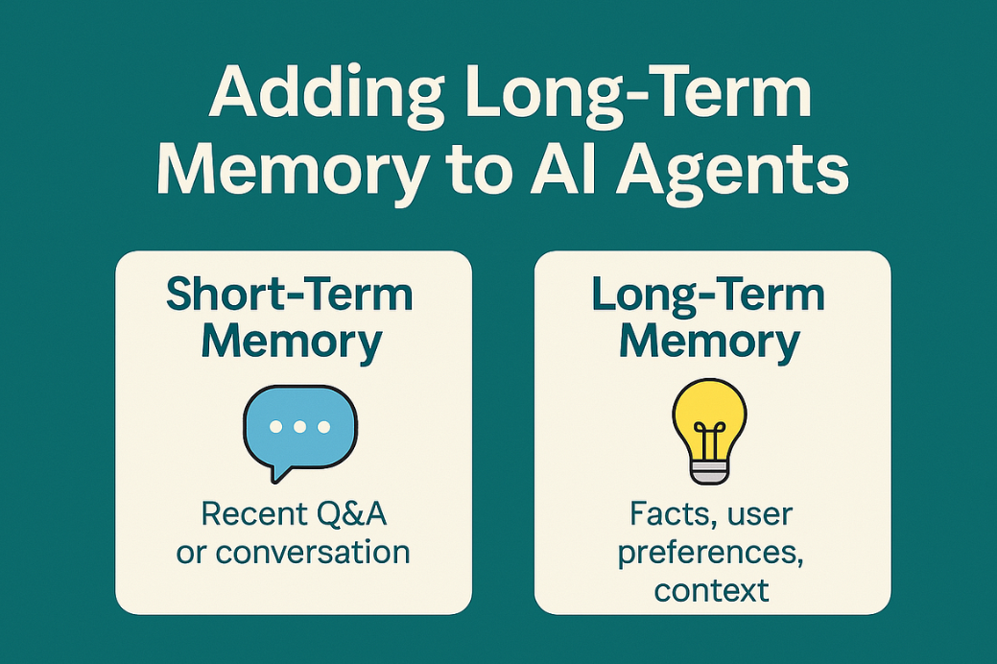

6. Rate Limits, Retries, Fallbacks & Cost Optimization

Use tenacity for retries:
from tenacity import retry, stop_after_attempt, wait_exponential

@retry(stop=stop_after_attempt(5), wait=wait_exponential(multiplier=1, min=2, max=10))
def safe_ask_llm(...):
...

Fallback routing:
models_to_try = [
"openai/gpt-4o-mini",
"groq/llama-3.1-70b-versatile",
"deepseek/deepseek-chat"
]

for m in models_to_try:
try:
resp = ask_llm(..., model=m)
if resp: return resp
except:
continue
Current rough pricing/context (March 2026 snapshot):
- GPT-4o family: ~$0.15–$2.50 input / $0.60–$10 output, 128k–1M context
- Claude 4 variants: ~$3–$15 / M tokens, 200k context
- Gemini 2.x: ~$0.30–$10, up to 1M+ context
- Groq Llama/DeepSeek: 10–50× cheaper, 128k–2M context on some

7. Putting It All Together: Mini Shop Agent Example

Combine everything:
# shop_agent.py
def shop_agent(user_query):
# Retrieve long-term memory
docs = vectorstore.similarity_search(user_query, k=2)
memory_ctx = "\n".join(d.page_content for d in docs) or "No prior info."

system = f"You are helpful repair shop assistant in Bhopal. Use Hindi+English. Memory: {memory_ctx}"

messages = [{"role": "system", "content": system}, {"role": "user", "content": user_query}]

final = run_agent(messages, model="groq/llama-3.1-70b-versatile") # cheap & fast fallback
return final
Run: print(shop_agent("My Samsung screen cracked, book slot?"))

Bonus: Local / Open-Source (No API Cost)
Use Ollama for fully local:
# Install Ollama → ollama.com
ollama run llama3.1
Then in LiteLLM: model="ollama/llama3.1"
Or Groq for free/fast inference.

